Opens Eyes (Karen & Nora)

Target Group: Adults in HK (18up) who wear glasses

(Potential group: Ppl wear con)

Objective: Raise their awareness toward eye health & provide convenient and useful information for eye education

Solve the problem of where to get glasses(Top 10 most searched item)

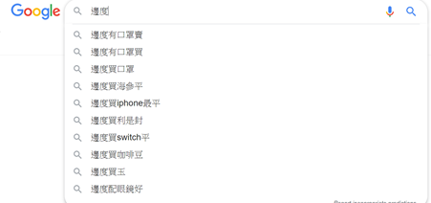

Evaluation means: Behavioral/ Value changes towards buying glasses, doing eye checkups and taking care of their eyes

Features:

*Openrice* [*https://www.openrice.com/en/hongkong*](https://www.openrice.com/en/hongkong)

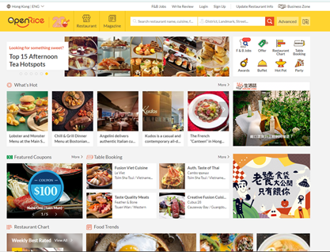

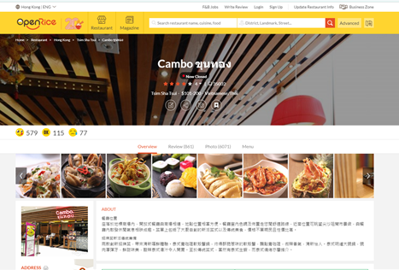

<https://www.openrice.com/en/hongkong/r-cambo-%E0%B8%82%E0%B8%B8%E0%B8%99%E0%B8%97%E0%B8%AD%E0%B8%87-tsim-sha-tsui-thai-r47405>

Details about each shop:

* Professional Qualification
* Checkup Equipment
* Kids-friendly
* Discounts/Price
* Stype of the glasses

Sharing platform: making comments and rating

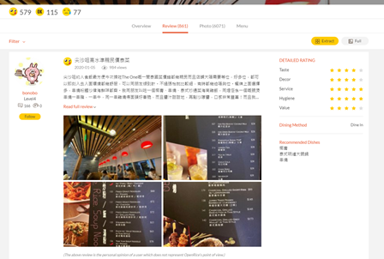

<https://www.openrice.com/en/hongkong/r-cambo-%E0%B8%82%E0%B8%B8%E0%B8%99%E0%B8%97%E0%B8%AD%E0%B8%87-tsim-sha-tsui-thai-r47405/reviews>

Data recordings: their checkup results

Education:

* Remind to do checkups - reminder
* Healthy Habit (practical video - step by step)

Partners:

Mr Dick Lo - optometrist (want life-long record, excel file)

* for his clients? for general public? always need to talk with parents

cuhk grp: individual group, have a regular check-up (secondary and primary students)

Link about cuhk grp: <https://www.ovs.cuhk.edu.hk/%E7%A4%BE%E5%8D%80%E6%B4%BB%E5%8B%95/%E4%B8%AD%E5%A4%A7%E8%B3%BD%E9%A6%AC%E6%9C%83%E5%85%92%E7%AB%A5%E7%9C%BC%E7%A7%91%E8%A8%88%E5%8A%83/%E8%A8%88%E5%8A%83%E7%B0%A1%E4%BB%8B/>

Problem:

hk eye hospital ? collaborate with them

- built connection with hospital (data recording, checkup info of the clients in apps)

- making a life-long record

Charile apps ( can be extend in our project):

* eye check-up collections for hospital, school ~~( using for remote check-up)~~
* more hospital oriented

Flutter SDK - cross platform development (open version)

*can include education/promotion/openeyes(it is a patient oriented)

* 2 apps (1 - hospital in mainland, an app for that hospital only & 2 - new version: ~~remote checking~~ for data collection only with no target group)

Data collections: (problem - cannot access past record easily)

→ education them (data visualization - provide the data)

→ easily to access previous data anytime (good for doctors and parents)

→ kids’ vision change rapidly(data visualization)

problem in HK (eye):

* store didn’t record the data of clients, make a paper for patients to check
* when there is a need, they will go to the eye checkup
* different stores have different standard and quality
* adult does not care their eye health

**Discussion Result**

Using charlie app as a backbone (Data collection: like a google form)

Problem 1: Flexible input form or Fixed input form

Problem 2: Who input the data? Doctor or Parents

Target Audience: Parents in Hong Kong(first stage: those who participated in CUHK eye hospital) Record data of their kids. Educate kids to take care of their eyes. Educate parents to change their kids' behaviour/ habits.

*Area: Hospital and Private hospital* Need further discussion, this could be potential development path, first stage focus on our partners(consent needed)

Objective: data collections (internal) and education (public)

Problem 1:

Do we collect the data for the doctor?(Maybe they already have a database and a data input system for themselves?)

For parents?(An individual account to save their own data)

For both?(A common database that will show updates for both parties)

Problem 2: What form of education? Data Visualization/Videos/Games?

Data Visualization: show trends and warnings. Would be nice if there are some kind of “healthy standard” for users to compare.

**Next Discussion (22/2 5:00pm HK):**

Confirm Data collection part

Brainstorm Education part

what should include in Literature review

Division of Labour

Charile demonstrating the apps

choose 1-2 people as contact person with partners(Tue/Wed phone meeting with Mr Lo)

**Discussion (notes) 22-02-2020**

Question: Data collection

individual account from parents

Charile demonstration:

Report

Data Collection App - all in chinese (eye checkup, vision checkup, summary of clients/patients = used for the staff in the hospital)

Login (ID + PW)

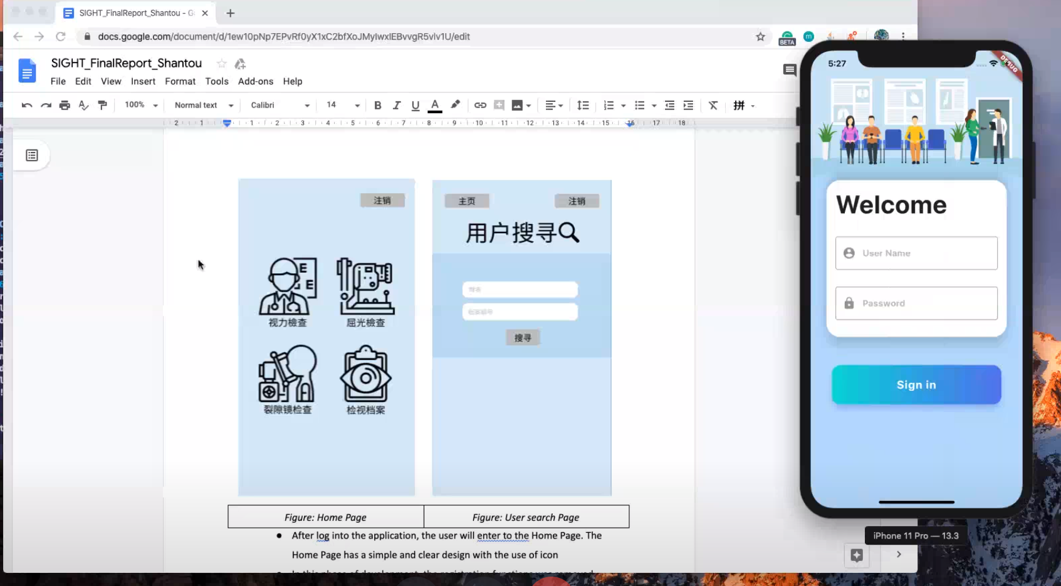

Search page (Name, ID number, Date of Birth) (for doctors to search)

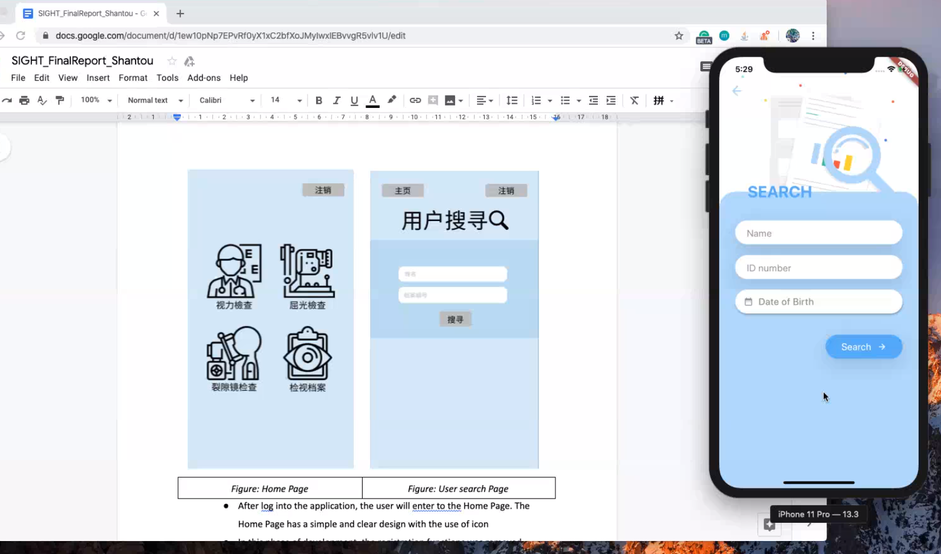

Users: doctors

* can be download in IOS and Android **(Flutter website)**

Front end, Back end

Collaborated hospital in mainland

Private issues - medical information, need to be considered and concerned

IT departments - import the server on their hospital server ( ~ us: hk eye hospital (only doctors can access the server? ) and personal server from sight)

Design process needed to be quicker

Prototype - 1 month (charlie experience)

No enough time to implement

* we can adjust and improve the prototype
* we have to design the direction clearly

Suggestion:

-discuss the (why do you want to join this course?) among the group

-charlie experience: bad teamwork

-before start doing it: real reason that you want to do it (new try things?)

-expectation to the project

Ian (18cred): boring in secondary school, college, learn somethings new in high school

Jaman (year 2):do what you can do, dirty work is okay, risk the core subjects (24 cred)

Nora (19cred) :want to do something meaningful, not care to be chur

Karen (22 cred, including capstone, YDC & one million): want to do something meaningful, want to make some changes in the world, admin work is okay, improve marketing and promotion skills, this course is more important

Tony (22 cred, alphasight, beauty industry, one million, BOA pitching): love to engage in some teamwork, entrepreneur, love practical work and apply the theory into the project, dun like really chur, enjoy the progress, this course is more important

Direction:

Jaman - VR eye idea (visualization - education); the graph is not good to understand for kids

Educate both parents and kids (focus on adults?)

Target group: adults

Eye hospital : stronger data ?

need to know number of patients

Ideas from Tony: (FUN) VR glasses: VR game (demonstrating), build up some workshops and educate in primary/secondary schools [education program]

(OpenEyes) : User generators; is it large demand? target audience? (market research) :

Openrice: more subjective vs openrice: more objective

OpenEyes: can be store generators rather than user generators

Target objective: adult ???

What are the problems to solve?

Problem: data collection by Dick Lo

Solution:

Tony idea: kids eye data into VR glasses, your future eye condition in demonstration (target audience: kids?)

-VR glasses - can be used as supplement; parents can see their kids’ eye condition

Workshop / collaborate the govt hospital / collaborate with laser hospital

Problem (by Jaman): Short-sighted in HK is serious

Target: both parents and kids or **mainly kids**

Where: eye hospital (below 18) / implemented at the school? hospital?

How: a new eye biological solution (change the behavior); education

Objective: Change the eye behaviors of kids(maintain a good eye health to keep them prevent from near-sighted)

* can we work on database on cuhk? will they give us database (20 years)? [support]

-VR game (know the eye problem, pick up an apple)

-VR game (filter the street - short sight (100,200,300 degree) vs normal - fear effect)

Database (data collection) → VR glasses (extension) (CS final year project from Alex Lam)

Literature Review (division of labour) (finalize the ideas with partners, editing a video) (1 hr)

**Background** : short-sight problem of teengers in HK : **Karen & Jaman**

**Marketing search: Tony & Ian**

Situation of population and areas : HK

Understanding and analysis of potential users: kids/ pri and secondary school/ hospitals

Similar tech/solutions: (apps used by doctor - charlie) + VR glasses (fear effect) + auto msg to parents (trackers) [database, server, VR glasses]

**Strengths and weaknesses (Karen & Jaman)**  of existing solutions: department of health (long and short -sight solution)

Any gaps in **existing solutions:(Tony & Ian)**

& Jaman) so **our solution (Nora & Dogu)**

The opportunities to make your proposed solution distinctive to these existing solutions:

28/2 first draft (29/2 rehearsal)

25/2 Dick Lo (Tue is better)

-tell him our ideas and get his data (he can use our app later, no need to use excel anymore)

-show him our prototype => show the prototype to CUHK at later stage when we can contact them more easily

**Discussion Result**

Project direction: Myopia VR simulation + A system for doctor to do data collection(Charlie’s app as backbone)

Target Audience: Kids/Parents

Target Problem: more and more kids have nearsightedness(myopia), prevent eye disease from young age, keep longitudinal record(decided to be viewed by doctor only for now), send wts toi the patients for reminder.

Solution:

Myopia VR simulation:

* Customize experience based on data collected
* Experience what it likes to have a certain degree of myopia in the future
* For now just like a 3D video with filter, no interactive elements

Problem 1: How long will the experience be? Too short: little to no effect; Too long: lengthen the checkup time

Problem 2: One-time only experience? or everytime after the checkup?

Problem 3: Why VR? Physical glasses to simulate blurry vision exists

Data Collection:

* Charlie’s app
* Doctor fill in the information and save to database
* Automatically send whatsapp/email to parents to give them tips/reminder

Questions for CU:

Database available? Where to implement server?(Hospital/Our private server)

Advisor on simulation

Any data collection method now? Maybe we just need to implement the VR part?

Question for Mr. Dick Lo:

Suggestion on the idea now

He wants data collection but does he want patients to view the data? or just himself?

Is it possible to give us data to work on?

Question for SIGHT/advisor: VR equipment support

Literature Review Structure and Division of Labour(See whatsapp and above)

Future Plan:

27/2 Discuss project idea with advisor, revise idea and work on literature review

28/2 Team Time: first draft

29/2 Presentation Rehearsal

Some Existing Blurry vision simulator online

<https://www.myeyedr.com/vision-simulator>

<https://visionsimulations.com/index.htm>

<http://billauer.co.il/simulator.html>

<https://www.vspdirect.com/vision-hub/vsp-vision-simulator>

Proposed VR game development tool

<https://aws.amazon.com/lumberyard/downloads/>